[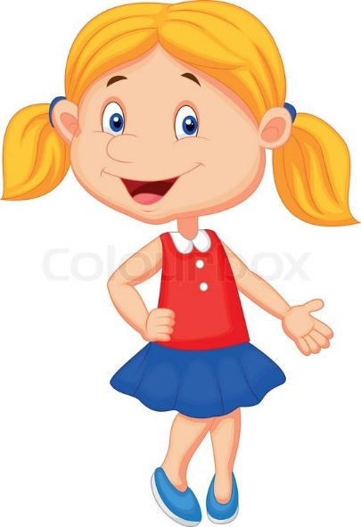](https://www.google.co.uk/url?sa=i&rct=j&q=&esrc=s&source=images&cd=&cad=rja&uact=8&ved=0ahUKEwiK7emxjMHXAhUE2hoKHc8zBIkQjRwIBw&url=https://www.colourbox.com/vector/cute-girl-cartoon-presenting-vector-8104989&psig=AOvVaw3qEGk6cx63CtotkLY-M4sB&ust=1510853039889510)

**I am** Sarah. **I’m** from Hamburg. **I have got** a blue dress

* This **is** Sarah.
* **She is** from Hamburg.
* [](https://www.google.co.uk/url?sa=i&rct=j&q=&esrc=s&source=images&cd=&cad=rja&uact=8&ved=0ahUKEwj7hquRosHXAhXO26QKHXqbDQwQjRwIBw&url=https://www.shutterstock.com/image-vector/orange-tabby-cat-cartoon-154191947&psig=AOvVaw2Lp5fqi7WHZ0E1w3dnoTWt&ust=1510858885781496)She **has got** a cat
* **It has got** stripes

**We are** from London! **We have got** basketballs

[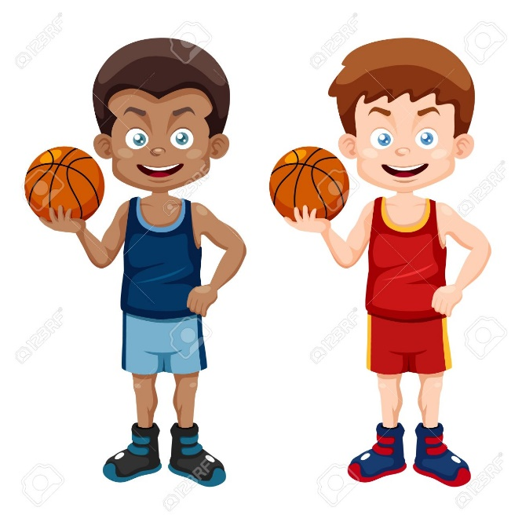](https://www.google.co.uk/url?sa=i&rct=j&q=&esrc=s&source=images&cd=&ved=0ahUKEwjbr4-7ksHXAhWDMhoKHQFNCCIQjRwIBw&url=https://www.123rf.com/photo_16392814_illustration-of-cartoon-basketball-player.html&psig=AOvVaw1dGB5VK01pB1BjeDzsyj07&ust=1510854655521993)

* **They are** from London
* **They’ve got** 2 basketballs
* **He’s got** blue shorts
* **He’s got** a red vest



**You are** my sister!

* **They are** brother and sister
* **She is** younger than him

**You have got** a blue T-shirt

* **He has got** a blue shirt